Member Details
Name | {{customer_name}}
Phone Number | {{contact_number}}
Date of Birth | {{dob}}
Gender | {{gender}}
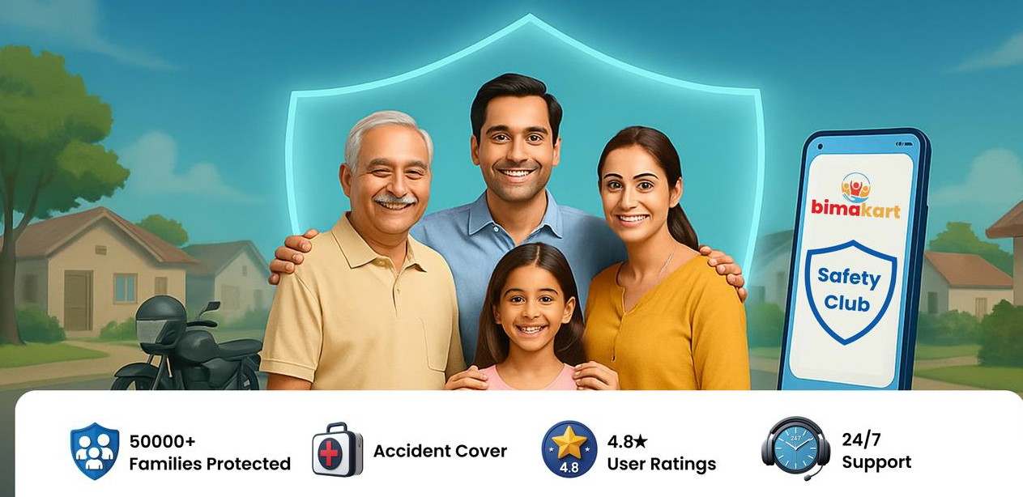
Platinum Membership
Membership Number
{{member_num}}
Membership Starts
{{issue_date}}
Membership Till
{{end_date}}
Order Details
Order ID | {{order_id}}
Purchase Date | {{issue_date}}
Membership Price | Rs. {{net_price}}
Total GST (18%) | Rs. {{gst}}
Total | Rs. {{selling_price}}

Group Personal Accident Details
Insurer | {{insurer}}
Master Policy Number | {{policy_number}}
Nominee Name | {{nominee_name}}
Nominee Relationship | {{nominee_relation}}




{{#offline_policy_name}}
{{#offline_policy_description}}

{{#online_policy_name}}
{{#online_policy_description}}

{{#policy_name}}
{{#t_and_c}}

